# Java application on github

Step 1.

Create a repository: <https://github.com/HarithaSarwa/practice_project_1_9>

Step 2.

Clone the repository to local.

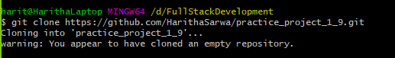

Step3.

Create a project using sts4 tool.

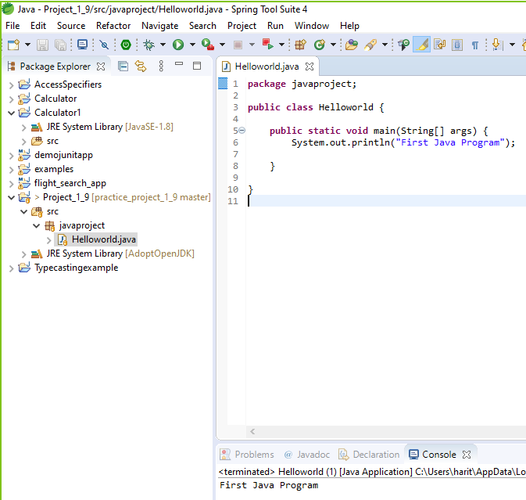

Step4.

Git status

checking for untracked files

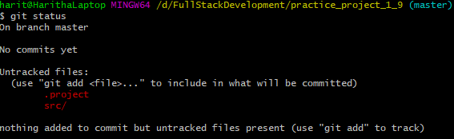

Step 5:

Commit changes to local repository

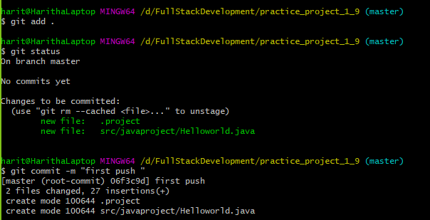

Step 6:

Push to remote repository

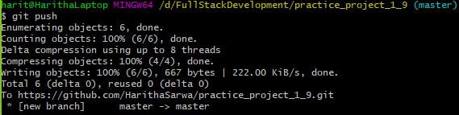

Step 7:

Check for untracked files that are not pushed to remote repository

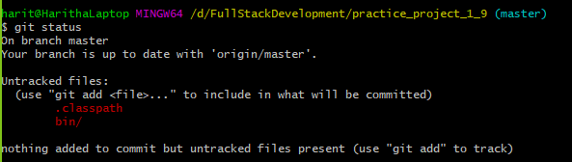

## Tracked files

* .project
* src/javaproject/Helloworld.java

## Untracked files

* .classpath
* bin/javaproject/Helloworld.class